CAMPUS CUSTOMER MANAGER HANDBOOK
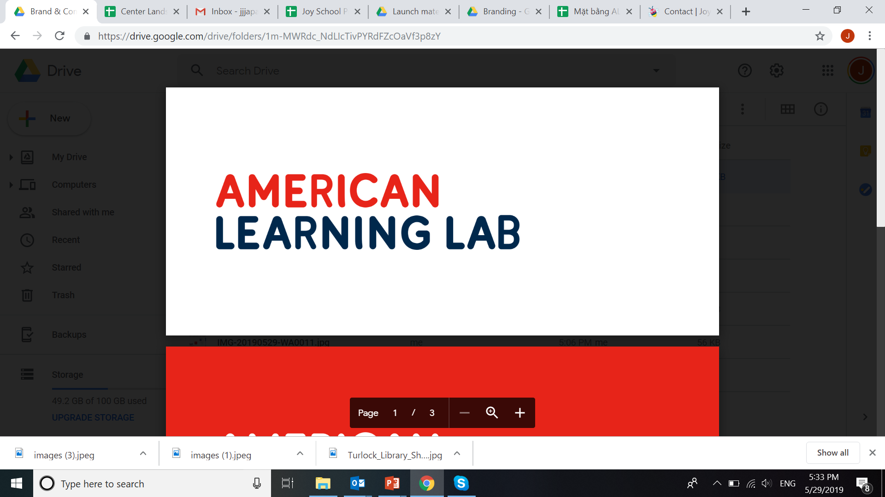

Introduction

As the new leader of your campus, this guide aims to provide CCMs with operations guidelines in order to effectively manage their designated campus.

Getting Started

Before you get started with studying these training materials, you must carefully watch the short videos listed below to get an overall, broad understanding of American Learning Lab.

Title | Video Link
Introduction to American Learning Lab | https://www.youtube.com/watch?v=N3aerkIT3x4
Introduction to Joy School English | https://youtu.be/7UeBa0lIn4o
Introduction to Envision Math | https://www.youtube.com/watch?v=hSzp-4KrxVI
What is CLIL? | https://www.youtube.com/watch?v=uIRZWn7-x2Y  https://www.youtube.com/watch?v=FEgY-_KFkKc
What is STEAM? | https://www.youtube.com/watch?v=5GWhwUN9iaY https://www.youtube.com/watch?v=vSAXJCPC5C4
What is Artificial Intelligence? | https://www.youtube.com/watch?v=nASDYRkbQIY
What are the 4Cs? | https://www.youtube.com/watch?v=BXT2STtm_54
What are the Cambridge Starters, Movers, Flyers exams? | http://www.cambridgeenglish.org/exams/young-learners-english/
What is the TOEFL exam? | https://www.youtube.com/watch?v=CXYq8IvPyaE
What is the IELTS exam? | https://www.youtube.com/watch?v=c-A9mTDHwGw

KEY CCM OPERATIONAL ITEMS

Key meetings for CCMs

- Weekly Campus Meetings (and one to one meeting with your Head Teacher weekly)

- Weekly CCM Meetings (All CCMs meet to discuss their region and results for the week with the Managing Director and Academic Managers/Heads)

- CCM huddles (CCMs need to huddle daily with key teams at their campus)

- Campus huddles or meetings (other leaders in your campus team need to huddle with their team members, for example the Head Teacher must huddle with their teachers and TAs)

- Monthly CCM and Head Teacher meeting for the whole region with the Managing Director and Academic Managers/Heads

- End of course / Monthly Parent Meetings

Key CCM Numbers to understand campus performance

- Teaching hours at your campus per month

- No of new sales daily, weekly and month

- Re-enrolment rate – End of payment period current students for the week and month

- Number of connected calls made by the EC team daily

- Number of registrations for PT / Demo made by the EC team daily

- No of PT/ Demo takers at your campus daily, weekly and monthly

- Conversion rates at each stage of the sales process

Key Procedures

- Academic Handbook - Guideline to Efficiency, Scheduling Procedures

- Customer Feedback/Complaints Handling Procedures

- Campus Daily Checklist (including HSE)

- Campus Sales Handbook

- CCP: Customer Care Procedure – the key procedure that outlines how we communicate with customers throughout their experience at Apollo

What the CCM should know about the Academic team

- Head Teacher monthly reports and observations

- Training workshops for teachers and TAs

- PT and Demo training

- Actions for improving re-enrolment

- Embrace 100% English environment

Key things to know about your neighborhood

- List of schools and how many students at each school

- Apartment blocks and how many families, students live there

- Bookshops, super markets, malls, parks, entertainment areas

- Key influencer parents who live in the area

DAILY OPERATIONAL GUIDELINES

EC (Sales Action Plan) | Check number of new sales yesterday
 | Check number of PT/Demo takers yesterday
 | Review EC follow up plan for no-show up and committed but unpaid students yesterday
 | Delegate list of students to call for renewal rate, actions for renewal
 | Listen to connected calls to confirm PT/Demo today
 | Check and monitor PTs, Demos and forecast sales today
 | New classes today that are opening, confirm with ECs and Head Teacher
 | Upgrading classes today (if any)
 | EC Coaching
Marketing | Marketing activities checks (if any)
 | No of leads yesterday
Academic | Welcome new teachers/TAs (if any)
 | Cancel/Make up classes (if any)
 | Observe classes
Meeting/Reports | - Daily with whole team and separate departments if needed  - Weekly Campus Meetings (and one to one meeting with your Head Teacher weekly)  - CCM huddles (CCMs need to huddle daily with key teams at their campus)  - Campus huddles  - Monthly CCM and Head Teacher meeting for the whole region with the Managing Director and Academic Managers/Heads  - End of course / Monthly Parent Meetings
Systems | Check financial, systems and customer data is correct and accurate

WEEKLY OPERATIONAL GUIDELINES

Day | Content
Monday | Tasks to complete and items to review  - Revenue update vs. target  - New sales action plan with each ECs – including telesales calls  - Renewal action plan  - Customer feedback  - Upgrading classes  - Scripts and calls feedback  - Academic issues  - HSE  - Working plan for this week  - Internal training/coaching for EC team (if any)  - Other issues
 | EC timetable checks & number of connected telesales calls
 | PT/Demo schedule checks
 | No of PT/Demo registers checks
 | Daily Huddle
MKT Meeting
- Target leads for this week (relevant to target new sales)
- Events this week (outside/inside)
- Digital leads (if any)
- Call To Action for this week
- Review monthly/quarterly plan
 | Review campus renewal & sales action plan for the week
 | Prepare weekly reports
Tuesday | City wide CCM weekly meeting
 | Daily Huddle
Wednesday | - Random check – Campus observations, lobby time with students and operating classes  - Weekly Meeting with Head Teacher  - Team Daily Huddle - 2.30 pm – led by CM
Thursday | Weekly Campus Meeting (WCM): COMPULSORY and MINUTES to be saved and shared with MD.  - Head Teacher summary on academic issues  - Customer feedback  - Teacher’s recruitment  - HSE  - New sales action plan with each ECs – including telesales calls  - Renewal action plan  - Others
 | Check general schedule
 | Daily Huddle
Friday | - Observe & support EC team  - Daily Huddle
Weekends  (Saturday) | - Observe & support EC team  - Troubleshoot  - Monitor calls, registrations, shows and sales
Timeline | Content
2nd of the month | Check teaching hours report sent by Head Teacher
 | Check Head Teacher report and observations
7th of the month | Opening/Closing classes for next month/next quarter
 | Revenue plan/estimation for next month/next quarter
15th of the month | Monthly CCM and HT meeting with MD and Academic Managers / Heads
20th of the month | Monthly/Quarterly MKT plan for next month/next quarter
 | Staff timesheet checks
 | P&L check and comments on campus performance
 | Review revenue plan/estimation for next month
 | Monthly campus meeting (20th – 25th)
 | Check commission reports
30th/31st of the month | TA and HT meeting monthly
 | Teacher’s meeting
 | HSE checklist and fire drills
 | Check revenue report

